**7805**

**7805** is a**voltage regulator**integrated circuit. It is a member of 78xx series of fixed linear voltage regulator ICs. The voltage source in a circuit may have fluctuations and would not give the fixed voltage output. The **voltage regulator IC** maintains the output voltage at a constant value. The xx in 78xx indicates the fixed output voltage it is designed to provide. 7805 provides +5V regulated power supply. Capacitors of suitable values can be connected at input and output pins depending upon the respective voltage levels.

**Pin Diagram:**

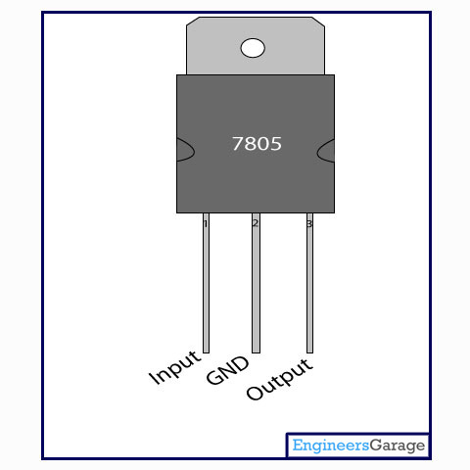

**L293D** **motor driver IC**

**Image:**

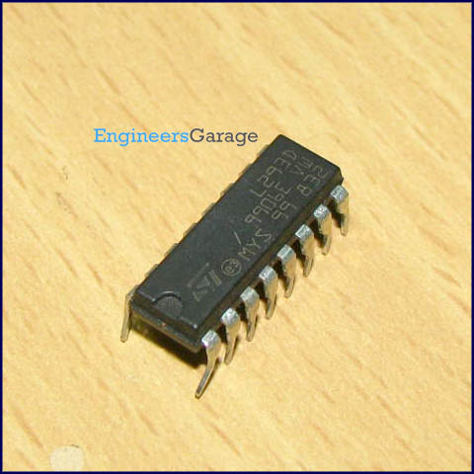

L293D is a dual [H-bridge](http://www.engineersgarage.com/electronic-circuits/h-bridge-motor-control) motor driver integrated circuit (IC). Motor drivers act as current amplifiers since they take a low-current control signal and provide a higher-current signal. This higher current signal is used to drive the motors.

L293D contains two inbuilt H-bridge driver circuits. In its common mode of operation, two DC motors can be driven simultaneously, both in forward and reverse direction. The motor operations of two motors can be controlled by input logic at pins 2 & 7 and 10 & 15. Input logic 00 or 11 will stop the corresponding motor. Logic 01 and 10 will rotate it in clockwise and anticlockwise directions, respectively.

Enable pins 1 and 9 (corresponding to the two motors) must be high for motors to start operating. When an enable input is high, the associated driver gets enabled. As a result, the outputs become active and work in phase with their inputs. Similarly, when the enable input is low, that driver is disabled, and their outputs are off and in the high-impedance state.

**Pin Diagram:**

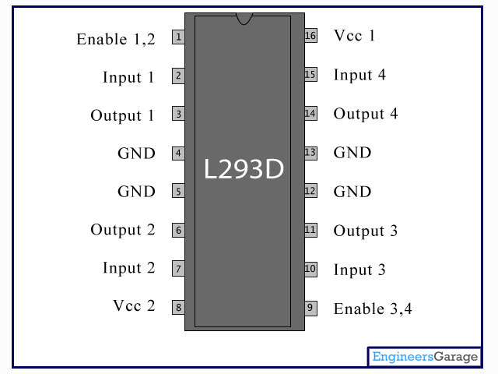

**Pin Description:**

|  |  |  |
| --- | --- | --- |
| **Pin No** | **Function** | **Name** |
| 1 | Enable pin for Motor 1; active high | Enable 1,2 |
| 2 | Input 1 for Motor 1 | Input 1 |
| 3 | Output 1 for Motor 1 | Output 1 |
| 4 | Ground (0V) | Ground |
| 5 | Ground (0V) | Ground |
| 6 | Output 2 for Motor 1 | Output 2 |
| 7 | Input 2 for Motor 1 | Input 2 |
| 8 | Supply voltage for Motors; 9-12V (up to 36V) | Vcc 2 |
| 9 | Enable pin for Motor 2; active high | Enable 3,4 |
| 10 | Input 1 for Motor 1 | Input 3 |
| 11 | Output 1 for Motor 1 | Output 3 |
| 12 | Ground (0V) | Ground |
| 13 | Ground (0V) | Ground |
| 14 | Output 2 for Motor 1 | Output 4 |
| 15 | Input2 for Motor 1 | Input 4 |
| 16 | Supply voltage; 5V (up to 36V) | Vcc 1 |

**How Crystal Oscillator, Resonator works**

**TABLE OF CONTENTS:**

1. **Insight - How Crystal Oscillator, Resonator works**
2. [**Metal Casing**](https://www.engineersgarage.com/insight/how-crystal-oscillator-resonator-works?page=2)
3. [**Crystal Plate**](https://www.engineersgarage.com/insight/how-crystal-oscillator-resonator-works?page=3)

A quartz crystal resonator plays a vital role in electronics oscillator circuitry. Sometimes mispronounced as crystal oscillator, it is rather a very important part of the feedback network of the oscillator circuitry. Electronics oscillators are used in frequency control application finding their usage in almost every industry ranging from small chips to aerospace.

 A quartz crystal is the heart of such type of resonators. Their characteristics like high quality factor (Q), stability, small size and low cost make them superior over other resonators like LC circuit, turning forks, ceramic resonator etc.

 The basic phenomenon behind working of a**quartz crystal oscillator**is the inverse piezo electric effect i.e., when electric field is applied across certain materials they start producing mechanical deformation. These mechanical deformation/movements are dependent on the elementary structure of the quartz crystal.  Quartz is one of the naturally occurring materials which show the phenomena of piezo electricity, however for the purpose of resonator it is artificially developed since processing the naturally occurring quartz is difficult and costly process.

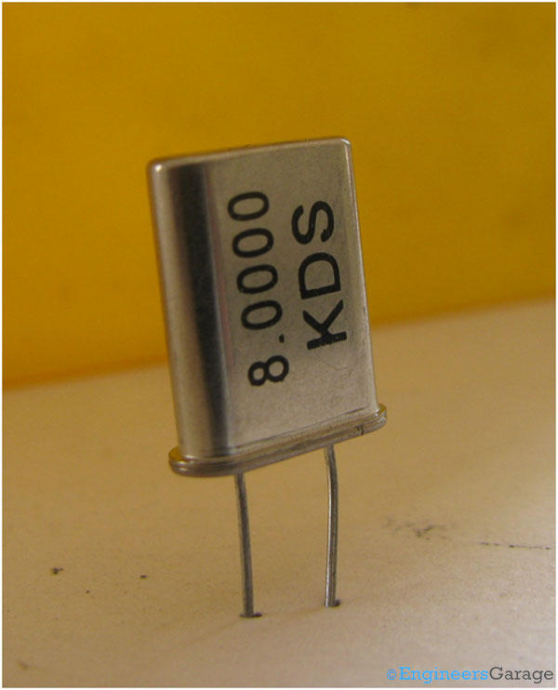

The image above shows a commonly used quartz crystal resonator. It is widely used in electronic oscillators circuitry used in digital [circuits](http://www.engineersgarage.com/electronic-circuits) and microcontroller/processors.